1. Private LeaderBoard Visualization

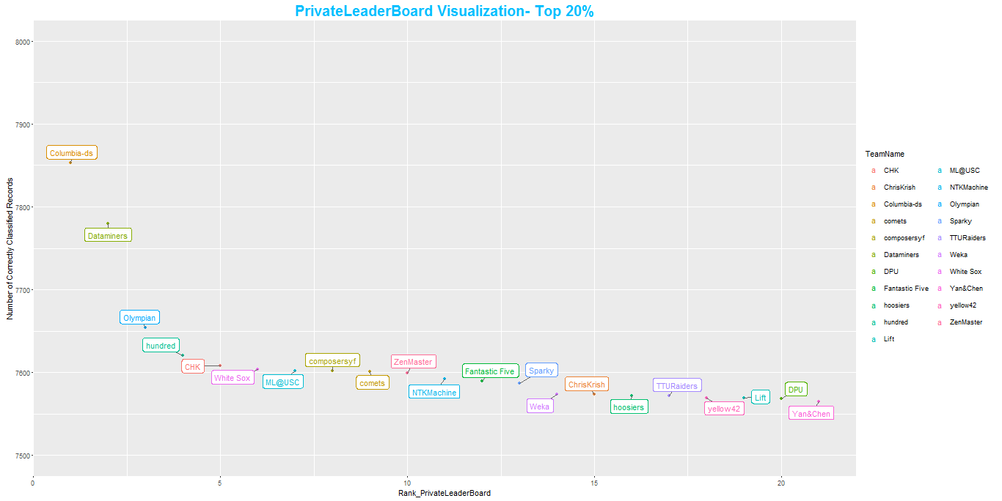

1. Rank shift from public to private LB

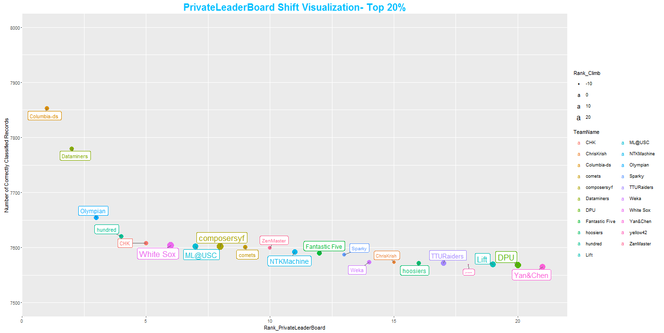

Impact of submissions on rank in private LB

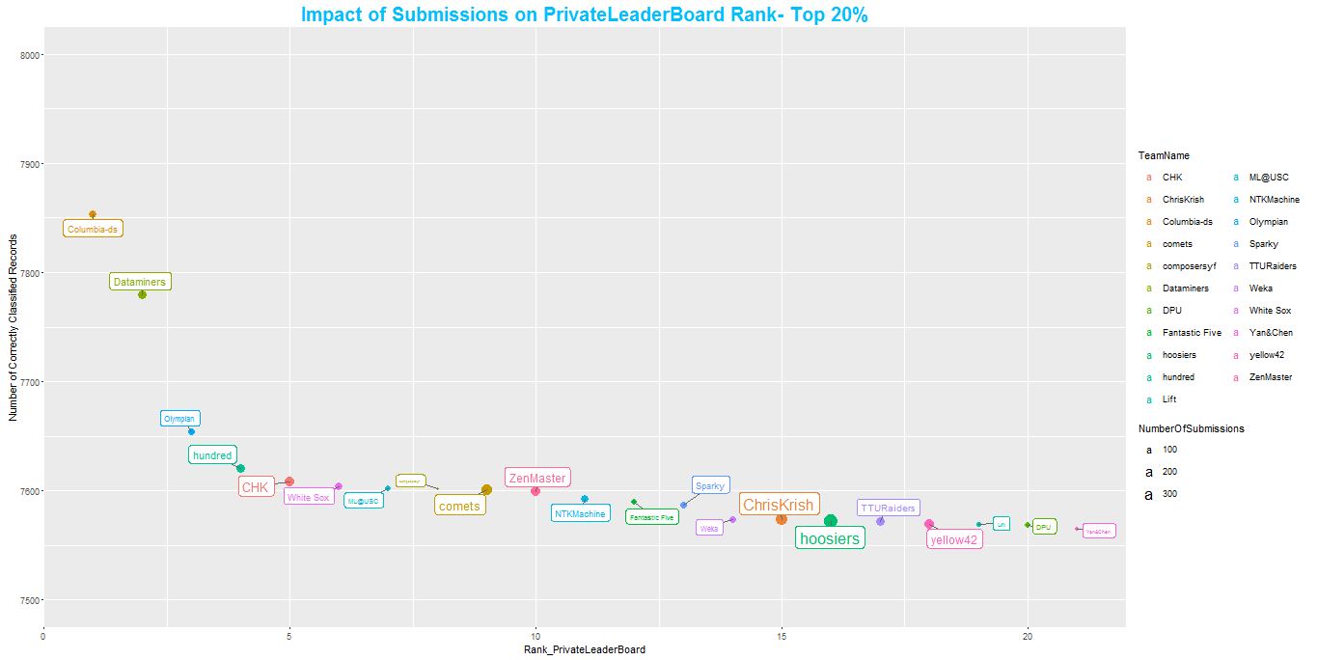

Impact of TeamSize on PrivateLeaderBoard Rank- Top 10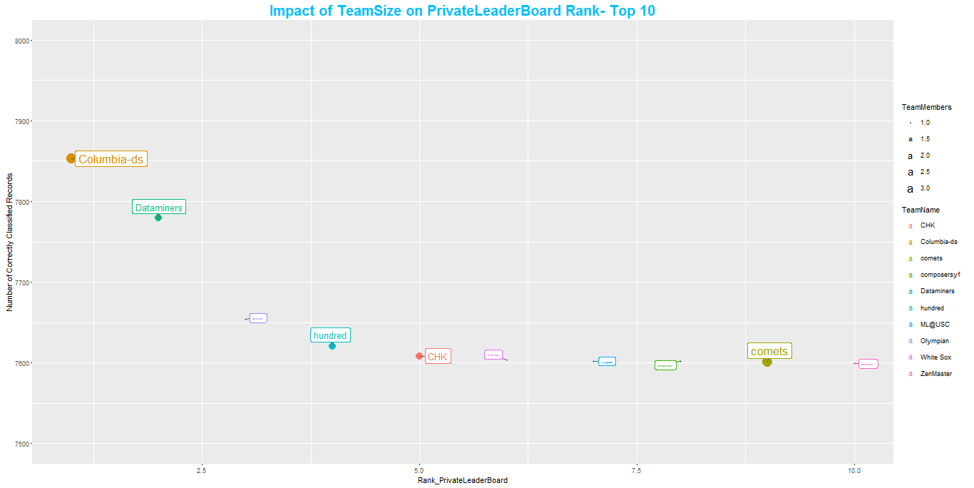

Toppers Composition : University Representation in Top20%

